**Processes in river basin hydrology and water management  
Exercise 1 – Catchment Functioning, Macroscale Laws & Change**

Please upload the completed assignment to the Brightspace site of the Module .

**Problem 1:**

1. Plot the 3 catchments, whose data are given in the Excel file “Catchment water balance data” in the Budyko framework (important: also plot the lines of the water and energy limit!)

- using the **analytical formulation** developed by Budyko (1948; see lecture slides) and

- directly using the **water balance data** given the excel file (without the use of the Budyko formula!)

1. analyse the **difference** between the 2 methods (is it possible what you see? Yes/no? Why?)
2. Calculate the complete(!) **long-term water balances** for the three catchments. Use the precipitation P and runoff Q data from the excel file and calculate actual evaporation Ea using the Budyko formula. (Hint: for long-term estimations it can be considered that dS/dt=0!)

**Problem 2:**

For two catchments, construct and plot the **flow duration curves** using data given in the Excel file “Flow duration curve data”.

Analyse what the **shape** of the flow duration curves tells you about the two catchments. Which one of them responds faster and has flashier peaks? Which one of them has a more regular flow regime? How can you see that?

**Problem 3:**

For two catchments, construct and plot the **autocorrelation functions** with time lags of 0,1,2,3,…30 using data given in the Excel file “Autocorrelation function data”.

Analyse what the **shape** of the autocorrelation functions tells you about the two catchments. Which one of them responds faster and has flashier peaks? Which one of them has a more regular flow regime? In which catchment longer term storage (e.g. groundwater) plays a larger role? How can you see that?

Is an autocorrelation function of stream flow as show in Figure 1 below physically possible? If yes, why and what does it show? If not, why?

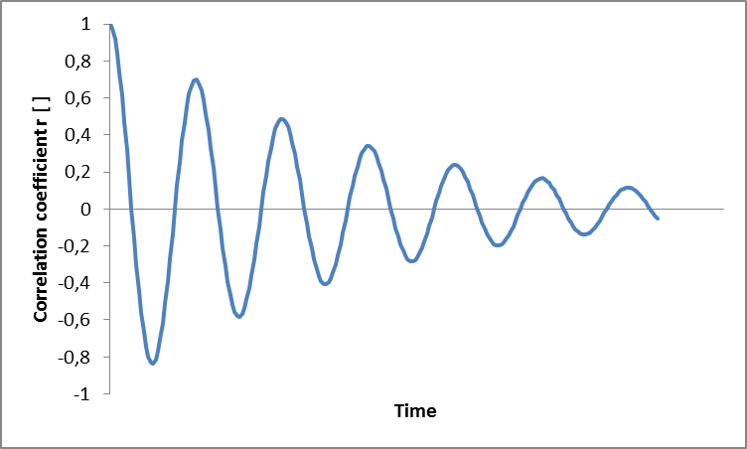

0

365

1095

1825

2190

1460

**Time lag [d]**

730

Figure 1: Stream flow autocorrelation function of a catchment